ARE YOU WILLING TO PLAY ALL OUT?
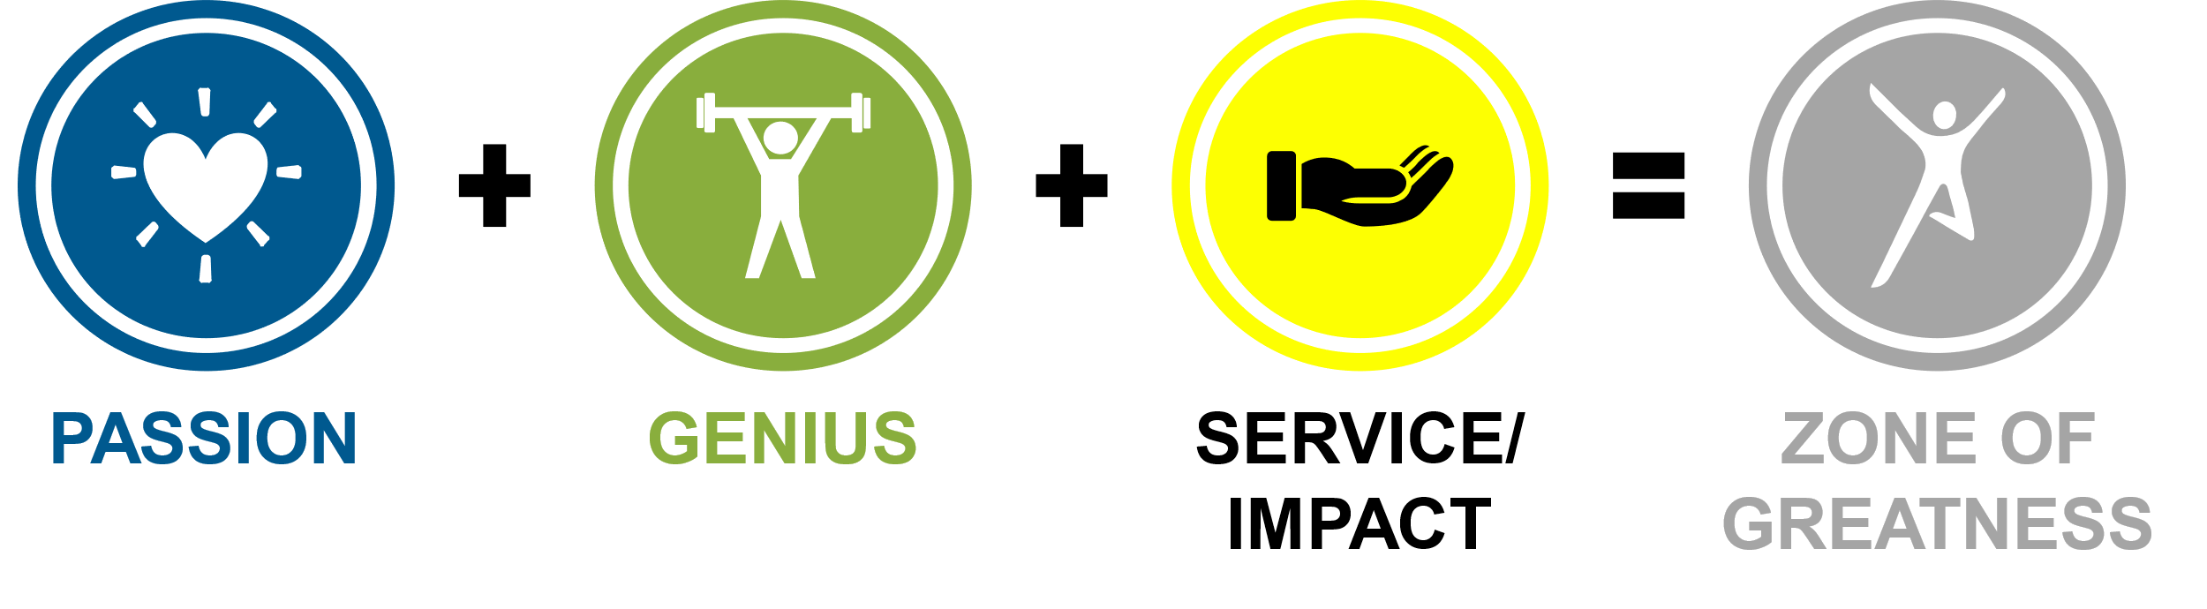

KNOW YOUR ZONE OF GREATNESS (ZOG)
PART 1 – PASSION
 |  | Xed  OUT | Selected
 | When I was a child, I dreamed of
 | I can’t pass up a book/movie/tv show about
 | If I took off work for a week, I’d spend the time
 | Most people don’t know this about me, but I really enjoy
 | I am the go-to person when my friends need help with
 | If I could star in my own how-to TV show, it would be about
 | If I were to make a homemade gift, it would involve
 | I’ve tried it only once or twice, but I really enjoy
 | The closest I come to a runner’s high is when I’m
 | If I won first prize in a talent show, it would be for

WRITE YOUR TOP 3 PASSIONS

PART 2 – GENIUS | PART 3 – SERVICE/IMPACT

ZOG STATEMENT

KNOW YOUR ZONE OF GREATNESS (CONT’D)
How does your ZOG align with WAPA’s vision and mission?

DEFINE THE GAME
CONSCIOUS GAME (Inner Work)

What inner work could you focus on to become a more creative leader? Define the actions you plan to take…

“Sadly, developing our leadership effectiveness often gets side-lined because we resist the vulnerability of learning and changing. It takes courage to face the truth about ourselves. The truth shall set us free, but first it may make us miserable.” ~ Robert J. Anderson & William A. Adams

COMPETENCE GAME (Outer Work)

What areas could be sharpened to improve your leadership effectiveness? Define the areas and actions you plan to take…
AREAS OF IMPROVEMENT | ACTION ITEMS

FIND YOUR “GO TO” AND PERFECT IT
What elements of your overall leadership game do you excel at?

Mastering leadership is definitely possible, however it will require your time and effort. As stated by the authors of Mastering Leadership, “mastering leadership is neither common nor common sense. It is uncommon sense. There are no shortcuts to greatness. As T.S. Eliot said, it will ‘cost not less than everything.’ It is worth the cost.” With that, I say, “you got this!” ~Anita “AC” Clinton

